W4D1 Homework Answers

1. Design the tables in database, attention their relationship and the constraint (primary key, foreign key)

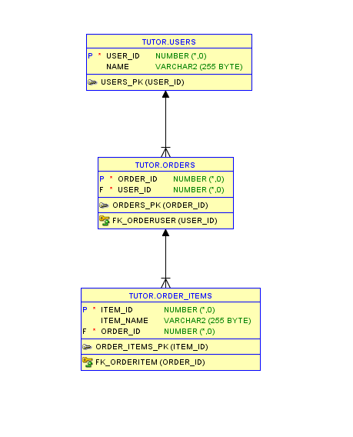

SQL Code:

**CREATE TABLE Users**

**(**

**User_Id int NOT NULL,**

**Name varchar(255),**

**PRIMARY KEY (User_Id)**

**);**

**CREATE TABLE Orders**

**(**

**Order_Id int NOT NULL,**

**User_Id int NOT NULL,**

**PRIMARY KEY (Order_Id),**

**CONSTRAINT fk_OrderUser FOREIGN KEY (User_Id)**

**REFERENCES Users(User_Id)**

**);**

**CREATE TABLE Order_Items**

**(**

**Item_Id int NOT NULL,**

**Item_Name varchar(255),**

**Order_Id int NOT NULL,**

**PRIMARY KEY (Item_Id),**

**CONSTRAINT fk_OrderItem FOREIGN KEY (Order_Id)**

**REFERENCES Orders(Order_Id)**

**);**

1. What are DQL, DML, DDL and DCL for Database? And what their commands? And give examples for each one based the above tables “User”, “Order” and “OrderItem”.
2. DQL is abbreviation of Data Query Language. Used to retrieve the records / data from database.

* SELECT - retrieve data from the a database

**select * from users;**

1. Data Definition Language (DDL) statements are used to define the database structure or schema. Some examples:

* CREATE - to create objects in the database

**CREATE TABLE Users**

**(**

**User_Id int NOT NULL,**

**Name varchar(255),**

**PRIMARY KEY (User_Id)**

**);**

* ALTER - alters the structure of the database

**ALTER TABLE USERS**

**ADD ADDRESS VARCHAR(255);**

* DROP - delete objects from the database

**DROP TABLE ORDER_ITEMS;**

* TRUNCATE - remove all records from a table, including all spaces allocated for the records are removed

**TRUNCATE TABLE ORDER_ITEMS;**

1. Data Manipulation Language (DML) statements are used for managing data within schema objects. Some examples:

* INSERT - insert data into a table

INSERT INTO USERS VALUES(1, 'LANCE');

INSERT INTO USERS(USER_ID) VALUES(2);

* UPDATE - updates existing data within a table

UPDATE USERS SET NAME = 'JASPER' WHERE USER_ID = 2;

* DELETE - deletes all records from a table, the space for the records remain

DELETE FROM USERS WHERE USER_ID = 2;

1. Data Control Language (DCL) statements. Some examples:

* GRANT - gives user's access privileges to database

CREATE ROLE Lance;

GRANT SELECT,UPDATE ON ORDERS TO Lance;

* REVOKE - withdraw access privileges given with the GRANT command

REVOKE SELECT,UPDATE ON ORDERS FROM Lance;